

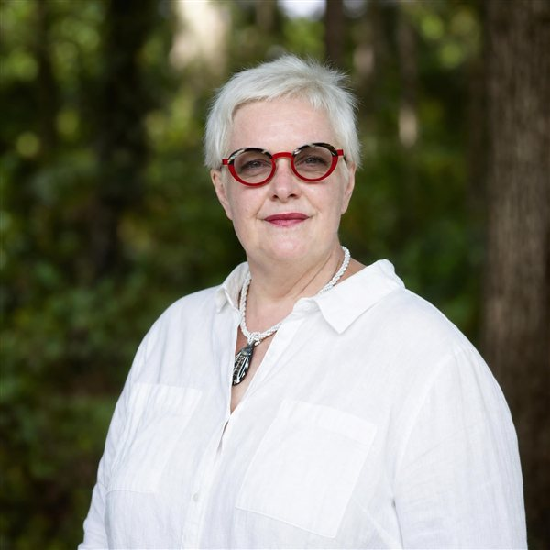  Isabelle Claus Teixeira  Co-Founder & Director · BHD Asia  CONTACT  Location  Kyoto, Japan  Phone  +81 80 6515 1778  E-mail  isabelle@bhdasia.com  Web  bhdasia.com  COACHING FOCUS  ▪ Executive Coaching  ▪ Transition & New-Leader Coaching  ▪ Performance & Career Coaching  ▪ Somatic Coaching & TRE®  ▪ 360° Debrief & Feedback  ▪ Conflict Management & Mediation  LANGUAGES  ▪ French — Native  ▪ English — Fluent  ▪ Spanish — Fluent | "Helping You Find & Forge Your Own Path"  Profile  Isabelle brings 27+ years of Senior HR Business Partnering, Regional Talent Management, and Organisational Effectiveness experience across Europe, the US, Asia, Japan and Russia. A certified leadership coach since 2012, she has lived and worked in 9 countries — connecting authentically with clients navigating the human complexities of international business.  Coaching Specialisations  • Executive, Transition, Performance & Career Coaching  • Somatic Coaching — body-based work integrated with neuroscience  • TRE® Provider & Trainer Trainee (Tension & Trauma Releasing Exercises)  • 360° Debrief & Multi-Perspective Feedback  Credentials & Certifications  • Certified Leadership Coach since 2012 — 1,300+ paid coaching hours  • PCC — International Coaching Federation  • Accredited Mediator — Singapore International Mediation Institute (SIMI)  • Forbes Coaches Council Executive Contributor & Brainz Magazine Contributor  • Accredited in Global Cultural Framework, Stakeholder-Centred Coaching, NeuroLeadership, Somatic & Team Coaching  Global Perspective  Fluent in French and English, Isabelle's multicultural background lets her engage meaningfully across cultures and industries — Automotive, Software, IT, Clinical Research, Trading, Shipping, Semiconductors, Pharmaceuticals, and Medical Devices.

